

SIMATS ENGINEERING
Saveetha Institute of Medical and Technical Sciences
IOT BASED SMART PARKING MANAGEMENT SYSTEM USING ER MODELING AND RELATIONAL DATABASE DESIGN
A CAPSTONE PROJECT REPORT
A Capstone Project Report submitted in partial fulfilment of the requirements for the Course of
CSA0501 – Database Management Systems
to the award of the degree of
BACHELOR OF ENGINEERING / BACHELOR OF TECHNOLOGY
IN
COMPUTER SCIENCE AND ENGINEERING
Submitted by
P. Jessica Hephzbah (192511425)
K. Tejaswi (192525407)
S. Swetha (192565101)
Under the Supervision of
Dr. Jaya Mabel Rani
SIMATS ENGINEERING
Saveetha Institute of Medical and Technical Sciences
Chennai-602105
SEPTEMBER 2026

SIMATS ENGINEERING
Saveetha Institute of Medical and Technical Sciences
Chennai-602105
BONAFIDE CERTIFICATE
This is to certify that the Capstone Project entitled "IoT Based Smart Parking Management System Using ER Modeling And Relational Database Design" has been carried out by P. Jessica Hephzbah (192511425), K. Tejaswi (192525407) and S. Swetha (192565101) under the supervision of Dr. Jaya Mabel Rani and is submitted in partial fulfilment of the requirements for the current semester of the B.Tech Computer Science and Engineering program at Saveetha Institute of Medical and Technical Sciences, Chennai.

COURSE COORDINATOR  Dr. Jaya Mabel Rani,  Associate Professor,  Department of Computer Science and Engineering,  SIMATS Engineering, SIMATS, Chennai – 602105. | COURSE FACULTY  Dr. Jaya Mabel Rani,  Associate Professor,  Department of Computer Science and Engineering,  SIMATS Engineering, SIMATS, Chennai – 602105.

SIMATS ENGINEERING
Saveetha Institute of Medical and Technical Sciences
Chennai-602105
DECLARATION
We, P. Jessica Hephzbah, K. Tejaswi and S. Swetha of the Department of Computer Science and Engineering, SIMATS Engineering, Saveetha Institute of Medical and Technical Sciences, Chennai, hereby declare that the Capstone Project Work entitled "IoT Based Smart Parking Management System Using ER Modelling And Relational Database Design" is the result of our own Bonafide efforts. To the best of our knowledge, the work presented herein is original, accurate, and has been carried out in accordance with the principles of engineering ethics and academic integrity. All sources, references, data, and other materials used in the project have been appropriately acknowledged. We further declare that the data, results, analysis, and findings presented in this report have not been fabricated, falsified, or manipulated. Any external tools, software, datasets, computational resources, or AI-assisted tools used during the project have been appropriately disclosed. We confirm that all applicable ethical, academic, institutional, and professional requirements have been duly followed throughout the planning, execution, analysis, and documentation of the project.
Place: Chennai
Date:
Signature of the Students with Names
P. Jessica Hephzbah
K. Tejaswi
S. Swetha

SIMATS ENGINEERING
Saveetha Institute of Medical and Technical Sciences
Chennai-602105
INDIVIDUAL CONTRIBUTION STATEMENT
(Mandatory for all team projects)
Student Name / Reg. No. | Specific Responsibilities | Design & Development Contribution | Testing & Analysis Contribution | Report Contribution | Approx. Contribution (%)
P. Jessica Hephzbah (192511425) | System architecture design; hardware module (IR sensors, ESP32) integration; database normalization | System architecture, ESP32-sensor integration, schema normalization | Functional testing of Module 1 (hardware & data acquisition) | Introduction, System Architecture, Components Used, Normalization, Module 1, Conclusion | 34%
K. Tejaswi (192525407) | ER modeling; relational database creation; database management module | ER diagram, relational schema, ParkingRecord/Sensor logic | Database consistency and foreign-key integrity testing | Literature Review, ER Modeling, Module 2 (Database Management) | 33%
S. Swetha (192565101) | Web application development; UI for slot display; results documentation | Web dashboard, real-time slot display logic | End-to-end testing, results comparison | Module 3 (Web Application), Results, Standards & SDG Mapping | 33%
Total: 100%

ABSTRACT
Urban parking is an escalating engineering problem: drivers routinely spend several minutes searching for an empty slot, manual attendant-based tracking is error-prone, and there is no way to check slot occupancy from outside the parking area. These inefficiencies increase local traffic congestion, fuel wastage and operational cost for parking facility owners. This project addresses the problem by designing and implementing an IoT-Based Smart Parking Management System that automatically senses slot occupancy and exposes it through a relational database and a live web dashboard.
The proposed solution uses infrared (IR) sensors at each parking bay, interfaced to an ESP32 microcontroller that also drives a 16x2 I2C LCD, status LEDs, a buzzer and a servo-actuated entry gate. Sensor states are transmitted over Wi-Fi in real time to a backend relational database, whose schema was derived from an Entity-Relationship (ER) model covering five entities: User, Vehicle, ParkingSlot, ParkingRecord and Sensor. The schema was normalized up to Third Normal Form (3NF) to remove redundant storage of owner and slot details across parking events, with all entities linked through primary and foreign keys. A lightweight web application reads the database and displays live slot availability to end users, removing the need for manual, in-person checking.
The methodology followed a standard embedded-systems-plus-database development cycle: requirement analysis, ER modeling, schema normalization, hardware prototyping on a breadboard, firmware development for the ESP32, database integration, and web-dashboard development, followed by functional and integration testing. The prototype was built and tested with three physical parking slots wired with IR sensors, a servo gate, LCD status display and LEDs.
Testing showed that the system correctly detected slot occupancy through the IR sensors, updated the ParkingSlot and ParkingRecord tables in real time, and reflected accurate available/occupied counts on the web dashboard within seconds of a status change. Compared with the manual/existing approach, slot detection time dropped from several minutes to a near-instant lookup on the application, and record keeping moved from paper-based logs to automatic database entries. The principal conclusion is that combining low-cost IoT sensing with a properly normalized relational database is an effective and extensible approach to smart parking management, and the design can scale to larger parking facilities with additional slots and sensor nodes.
Keywords: Internet of Things (IoT), Smart Parking, ER Modeling, Relational Database Design, Normalization, ESP32, Real-Time Monitoring

TABLE OF CONTENTS
Sl. No | Title | Page No
i | CERTIFICATE FROM THE SUPERVISOR | ii
ii | DECLARATION BY THE CANDIDATE | iii
iii | INDIVIDUAL CONTRIBUTION STATEMENT | iv
iv | ABSTRACT | v
v | LIST OF FIGURES | vi
vi | LIST OF TABLES | vii
vii | LIST OF ABBREVIATIONS | viii
1 | CHAPTER 1: Introduction and Engineering Problem | 1
2 | CHAPTER 2: Literature Review and Existing Solutions | 5
3 | CHAPTER 3: Engineering Design & Trade-offs, Sustainability, Ethics, Safety, Risk & Security | 8
4 | CHAPTER 4: Implementation, Testing & Results, Project Management | 14
5 | CHAPTER 5: Conclusion, Future Work and Reflection | 20
 | References | 22
 | Appendices | 23

LIST OF FIGURES
Figure No. | Figure Name | Page No.
1.1 | IoT Based Smart Parking Management System - System Architecture | 3
3.1 | ER Diagram - Smart Parking Management System | 10
3.2 | Relational Schema Derived from the ER Model | 11
4.1 | Circuit Diagram - ESP32, IR Sensors, Servo Motor, LCD, LEDs and Buzzer | 15
4.2 | Hardware Prototype Setup | 16
4.3 | Web Dashboard - Slot Status (Occupied) | 18
4.4 | Web Dashboard - Slot Status (Slot Freed) | 18

LIST OF TABLES
Table No. | Table Name | Page No.
3.1 | Stakeholder / User Requirements | 8
3.2 | Functional & Non-Functional Requirements | 9
3.3 | Constraints & Applicable Standards | 9
3.4 | Design Specifications | 10
3.5 | Alternative Solutions Evaluation Matrix | 10
3.6 | Trade-off Analysis | 12
3.7 | Sustainability, Ethics, Safety, Risk & Security | 13
3.8 | Risk Register | 13
4.1 | Components Used | 14
4.2 | Tools / Software / Equipment | 16
4.3 | Test Plan & Verification | 17
4.4 | Achieved vs Required Specifications | 17
4.5 | Results Comparison - Manual vs Proposed System | 18
4.6 | Achievement of Objectives | 19
4.7 | Roles & Responsibilities | 19
4.8 | Estimated vs Actual Cost | 19

LIST OF ABBREVIATIONS / SYMBOLS
Symbol | Description | Unit
IoT | Internet of Things | -
ER | Entity-Relationship | -
DBMS | Database Management System | -
ESP32 | Espressif 32-bit Microcontroller Module | -
IR | Infrared | -
LCD | Liquid Crystal Display | -
LED | Light Emitting Diode | -
PK / FK | Primary Key / Foreign Key | -
3NF | Third Normal Form | -
SDG | Sustainable Development Goal | -
WLAN | Wireless Local Area Network | -

CHAPTER 1
INTRODUCTION AND ENGINEERING PROBLEM

1.1 Background
Vehicle ownership in Indian cities has grown far faster than the parking infrastructure available to support it, and most educational campuses, malls and office complexes still rely on manual attendants or unmanaged first-come-first-served parking. At the same time, low-cost Wi-Fi enabled microcontrollers such as the ESP32, inexpensive IR proximity sensors, and cloud-friendly relational databases have made it practical for a small student team to build an end-to-end sensing-to-database-to-dashboard pipeline without specialised industrial hardware. This project sits at the intersection of embedded IoT sensing and database management: it uses IR sensors and an ESP32 to physically detect whether a parking slot is occupied, and a normalized relational database, designed from a formal ER model, to store and serve that information reliably to a web application.

1.2 Need for the Project
- Drivers currently have no way to know whether a parking slot is free before or during their search, so they drive around occupied areas, adding to congestion near entrances.
- Parking attendants who track occupancy by walking around or watching cameras are affected most directly; their manual process is slow and introduces recording errors.
- Facility administrators are affected indirectly, since paper or spreadsheet-based logs make it hard to audit how slots are used over time.
- Existing manual systems have no persistent, queryable record of entry/exit events, which limits reporting, billing, or future analytics.
- From an engineering standpoint, the significance of the project lies in combining a real-time sensing layer with a properly modeled and normalized relational database, rather than treating the database as an afterthought.

1.3 Problem Statement
Design and implement a low-cost IoT-based parking management system in which multiple IR sensors continuously report per-slot occupancy to an ESP32 microcontroller, which must reliably relay this data over Wi-Fi to a backend relational database whose schema is derived from a normalized ER model capable of tracking users, vehicles, slots, sensors and parking records without data redundancy, while simultaneously driving local indicators (LCD, LEDs, buzzer, gate servo) and serving live occupancy data to a web application, under the realistic constraints of intermittent Wi-Fi connectivity, limited microcontroller memory, sensor noise from dust or obstruction, and the need for referential integrity between hardware events and stored database records.

1.4 Project Aim
To design, prototype and evaluate an IoT-based smart parking management system that senses slot occupancy in real time and stores it in a normalized relational database, so that free slots can be displayed to users through a web application without manual checking.

1.5 Project Objectives
- To develop an IoT-based smart parking management system using IR sensors and an ESP32 microcontroller.
- To design an Entity-Relationship (ER) model and a normalized relational database for parking data (User, Vehicle, ParkingSlot, ParkingRecord, Sensor).
- To monitor parking slot occupancy in real time and transmit sensor status to the database over Wi-Fi.
- To display live parking availability to end users through a web application.
- To evaluate the system against the existing manual approach in terms of detection time, accuracy and record-keeping, and to identify avenues for scaling to larger parking facilities.

1.6 Scope

Included
- A prototype covering a small number of physical parking slots (3-4) instrumented with IR sensors, an ESP32 controller, LCD, LEDs, buzzer and a servo-actuated gate.
- A relational database with five tables (User, Vehicle, ParkingSlot, ParkingRecord, Sensor) designed from an ER model and normalized to 3NF.
- A web application that reads live slot status from the database and displays it to users.

Excluded
- Payment/fee collection, RFID-based vehicle identification, and automatic number-plate recognition are outside the current scope.
- Large-scale multi-storey parking with hundreds of slots and load-balanced servers is not implemented, though the design is extensible toward it.

Assumptions
- A stable Wi-Fi network is available within range of the ESP32 controller.
- Each parking slot has exactly one dedicated IR sensor and one associated status indicator.

Boundary Conditions
- The database and web application are assumed to run on a single backend server reachable by the ESP32 and by client browsers on the same network.

1.7 Expected Engineering Outcome
The expected outcome is a working hardware-software prototype: an ESP32-based sensing and gate-control unit, a normalized relational database that models users, vehicles, slots, sensors and parking records, and a web dashboard that reads that database to show live slot availability. Figure 1.1 shows the overall system architecture that ties these three layers together; it is discussed in further engineering detail as part of the selected design in Chapter 3.
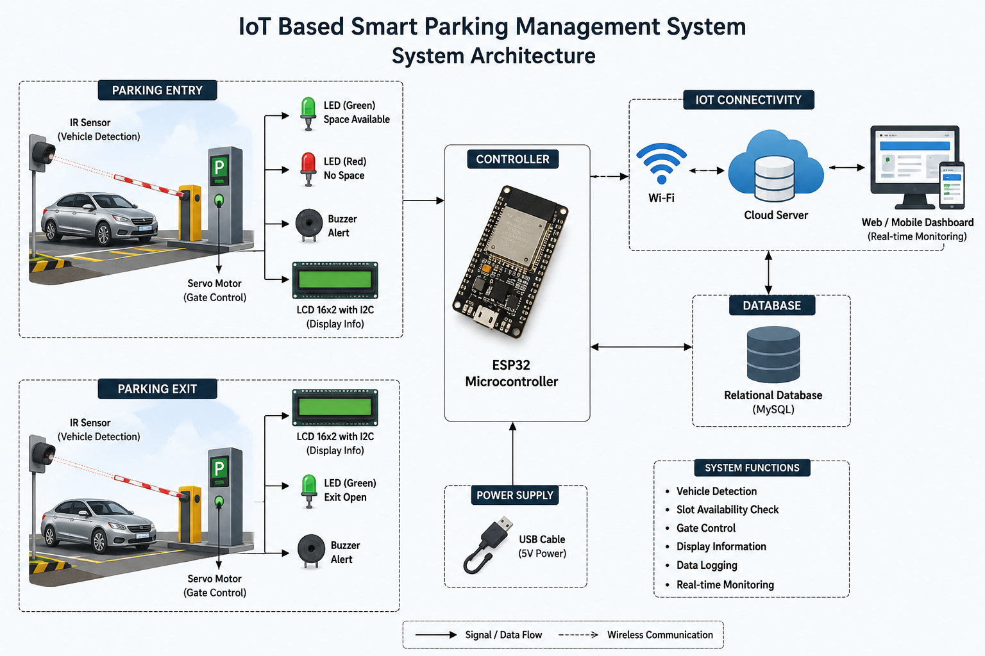
Fig. 1.1: IoT Based Smart Parking Management System - System Architecture

CHAPTER 2
LITERATURE REVIEW AND EXISTING SOLUTIONS

2.1 Review Method
Relevant work was identified by searching IEEE Xplore, ScienceDirect and conference proceedings (EAI/Springer, ACCESS) for papers combining the keywords 'IoT', 'smart parking', 'ESP32', and 'database' or 'relational schema', published mainly between 2020 and 2025. Preference was given to papers that described a full hardware-to-database pipeline similar in scope to this project, rather than purely simulation-based studies.

2.2 Review of Existing Work
D. Ashok et al. describe an IoT-based smart parking system using IR sensors and a DC-motor gate connected to the internet via a Wi-Fi modem, with a website used to display parking availability, but the paper does not detail a normalized relational schema behind the dashboard.
Rajasekaran et al. present a real-time monitoring system built specifically around the ESP32, close in spirit to the hardware layer used in this project, and confirm that ESP32-based sensing is a practical, low-cost approach for slot-level occupancy detection.
Simatupang et al. and Won et al. both report ESP32/NodeMCU based smart parking prototypes with mobile or web front-ends, reinforcing IR sensing plus microcontroller plus dashboard as a common and validated architecture pattern, though neither paper emphasises database normalization as a design step.
Existing Approach | Advantages | Limitations | Relevance to Proposed Work
IR sensor + DC motor gate + website (Ashok et al.) | Simple, low cost, validated concept | No documented database schema or normalization | Confirms IR + gate + web dashboard pattern; this project adds a normalized relational backend
ESP32 real-time monitoring (Rajasekaran et al.) | Directly validates ESP32 as sensing/controller hub | Focused on monitoring only, minimal data modeling | Basis for the Module 1 hardware design in this project
ESP32/NodeMCU + mobile app (Simatupang, Won et al.) | Working prototypes with app-based display | Database design not a focus; often uses flat storage (e.g. Firebase) | Motivates the relational, normalized approach taken here
OCR + ESP32 + MySQL, entry/exit tables (ScienceDirect) | Explicit entry/exit database tables, CRUD via backend script | Adds OCR complexity not required for slot-level occupancy | Entry/exit table pattern reused conceptually in ParkingRecord design
RFID + ESP32 + ThingSpeak fee system (IEEE 2025) | Adds identity and billing on top of ESP32 sensing | Cloud-only logging, not a normalized relational schema | Identified as a natural future-work extension (Section 5.2)
A ScienceDirect-indexed study on number-plate-recognition parking adds identity/OCR-based vehicle recognition on top of an ESP32 and MySQL database, and explicitly uses separate entrance and exit database tables updated via PHP scripts, which is architecturally similar to the ParkingRecord entry/exit design adopted in this project.
A 2025 IEEE conference paper on an automated smart parking fee system integrates RFID with ESP32 and ThingSpeak for cloud logging, illustrating how identity and billing features could be layered onto the present system in future work.

2.3 Comparative Analysis

2.4 Research / Engineering Gap
Across the reviewed literature, ESP32-based IR sensing for parking occupancy is well established, and web or mobile dashboards are commonly used to display results. However, most reviewed systems either do not document their backing data store at all, or use a flat/NoSQL store (such as Firebase or ThingSpeak channels) rather than a normalized relational schema derived from an explicit ER model. This leaves an engineering gap in demonstrating, end-to-end, how a formally modeled and normalized relational database (with User, Vehicle, ParkingSlot, ParkingRecord and Sensor entities linked by primary and foreign keys) can serve as the backend for a real-time IoT parking system.

2.5 Proposed Contribution
This project contributes a complete pipeline in which sensor events are grounded in a formally derived ER model, normalized to Third Normal Form, so that owner details, vehicle details and slot details are stored exactly once and linked through foreign keys rather than being repeated in every parking record. This differs from the reviewed systems, which either omit the database design step or rely on non-relational storage, and it makes the resulting schema easier to query, audit and extend (for example, to add billing or RFID-based identification, as noted in Section 2.2) without redesigning the underlying data model.

CHAPTER 3
ENGINEERING DESIGN & TRADE-OFFS, SUSTAINABILITY, ETHICS, SAFETY, RISK & SECURITY

3.1 Requirements

Stakeholder / User Requirements
Stakeholder | Requirement
Driver / User | Wants to see free parking slots before or on arrival, without walking around the lot
Parking attendant / staff | Wants automatic, error-free tracking of which slots are occupied
Facility administrator | Wants a persistent, queryable record of entries, exits and slot usage
System maintainer | Wants a database schema that is easy to extend (e.g., add billing) without redesign

Functional & Non-Functional Requirements
Requirement Type | Requirement | Measurable Target
Functional | Detect slot occupancy using IR sensors | Correct status for all 4 sensors, checked continuously
Functional | Update database record when a slot's status changes | Database reflects new status within 5 seconds of change
Functional | Display free/occupied slots on a web application | Dashboard shows current counts on page load/refresh
Functional | Open/close entrance gate automatically | Servo actuates gate within 2 seconds of a valid trigger
Non-functional | Reliability of Wi-Fi data transmission | No more than 1 missed update per 20 status changes in testing
Non-functional | Data consistency between hardware and database | Zero orphaned ParkingRecord rows (all FKs valid) in test runs

3.2 Constraints & Applicable Standards
Standard / Code | Requirement | How Applied in This Project
IEEE 802.11 (Wi-Fi) | Wireless LAN standard for data communication | Used for the ESP32-to-database link that carries sensor status updates
IEEE 1451 | Standard for smart sensors and sensor interfaces | Guided the interfacing approach between the IR sensors and the ESP32 controller
IEEE 2413 | Standard architecture for the Internet of Things | Provided the reference framework for structuring the sensing-to-database-to-dashboard layers
IEEE 830 | Software Requirements Specification standard | Used as a template for stating the functional/non-functional requirements in Section 3.1

3.3 Design Specifications
Parameter | Target/Requirement | Unit | Priority
Number of monitored slots | 4 | slots | High
Sensor-to-database update latency | <= 5 | seconds | High
Gate actuation delay | <= 2 | seconds | Medium
Microcontroller | ESP32 (Wi-Fi enabled) | - | High
Database normal form | 3NF | - | High

3.4 Alternative Solutions & Evaluation
Alternative 1: Camera-based occupancy detection using computer vision to classify each bay as occupied/vacant from an overhead camera feed.
Alternative 2: IR-sensor-based occupancy detection (adopted), where a dedicated IR proximity sensor per slot reports a binary occupied/vacant signal to the ESP32.
Alternative 3: RFID-tag-based detection, where each registered vehicle carries a tag read at the slot or gate to infer occupancy indirectly.
Criterion | Weight | Alternative 1 (Camera) | Alternative 2 (IR sensor) | Alternative 3 (RFID)
Performance | 30% | High accuracy, needs good lighting | Reliable for direct presence detection | Depends on tag registration, not presence itself
Cost | 25% | High (camera + compute) | Low (few INR per sensor) | Medium (tags + readers)
Safety | 15% | No physical risk | No physical risk | No physical risk
Sustainability | 15% | Higher power draw for image processing | Low power draw | Low power draw
Reliability | 15% | Sensitive to lighting/occlusion | Sensitive to dust/misalignment but simple to fix | Fails if tag missing or unregistered

3.5 Selected Design & Detailed Design
IR-sensor-based detection (Alternative 2) was selected because it scored highest on cost and sustainability while meeting the performance requirement for direct, per-slot presence detection, and it avoids the lighting sensitivity of the camera option and the tag-dependency of the RFID option. The selected design therefore centres on an ESP32 controller that reads four IR sensors and drives a servo gate, LCD, LEDs and buzzer, and that pushes status updates over Wi-Fi to a relational database read by a web application.

Fig. 3.1 (repeated as Fig. 1.1): System Architecture linking the sensing, controller, database and web-dashboard layers
The Entity-Relationship model below formalises the data side of the selected design. It captures five entities: USER (owns) VEHICLE, VEHICLE (through PARKING) generates PARKING RECORD entries, and PARKING RECORD references a PARKING SLOT which is (monitors) linked one-to-one with a SENSOR.
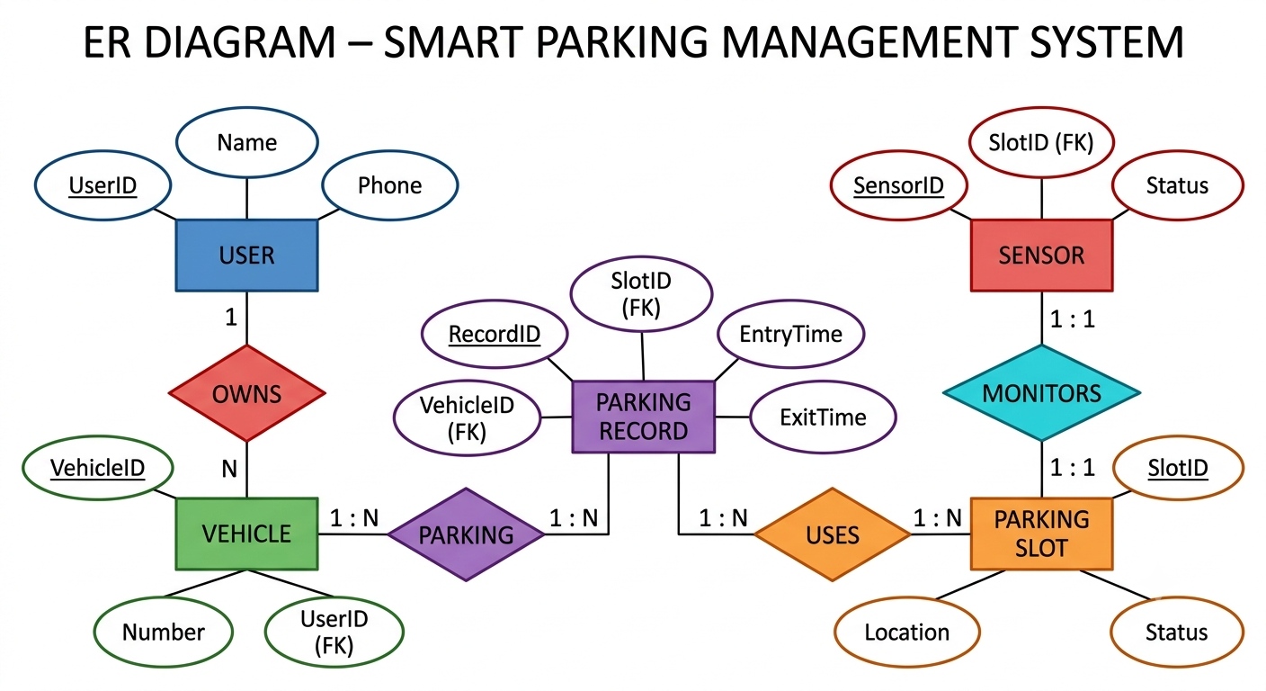
Fig. 3.2: ER Diagram - Smart Parking Management System
Translating the ER model into tables gives the relational schema in Fig. 3.3, with primary keys underlined in the ER diagram and foreign keys shown explicitly in the schema (VehicleID and SlotID in ParkingRecord; UserID in Vehicle; SlotID in Sensor).
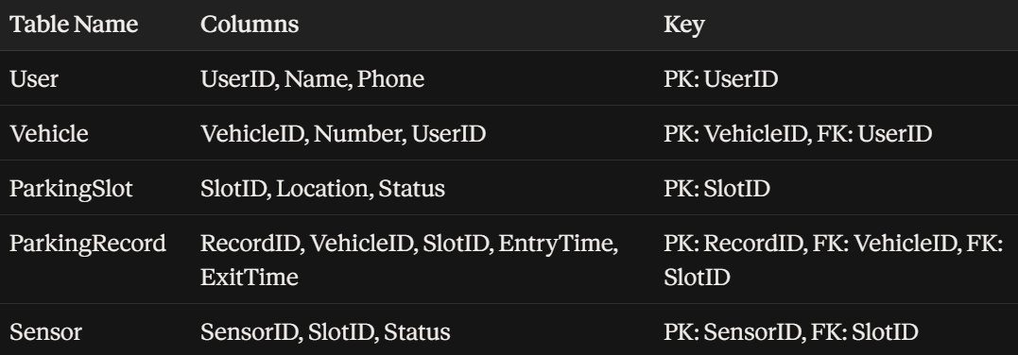
Fig. 3.3: Relational Schema Derived from the ER Model

Normalization
Without normalization, a single flat parking table would repeat the owner's name and phone number, the vehicle number, and the slot location on every parking event, wasting storage and risking inconsistent updates (e.g., a phone number changed in one row but not another). Normalization was applied as follows:
- 1NF: every column in each table holds a single atomic value (e.g., a vehicle's UserID is one value, not a list), and each table has a unique primary key (UserID, VehicleID, SlotID, RecordID, SensorID).
- 2NF: all tables use single-column primary keys, so there are no partial dependencies on part of a composite key to remove; every non-key attribute (Name, Phone, Number, Location, Status, EntryTime, ExitTime) depends on the whole of its table's key.
- 3NF: transitive dependencies were removed by splitting the data into five linked tables instead of one large table. Owner details live only in User, vehicle details only in Vehicle, and slot details only in ParkingSlot; ParkingRecord stores only the event-specific facts (EntryTime, ExitTime) plus foreign keys (VehicleID, SlotID) back to the other tables, and Sensor stores only sensor-specific facts (Status) plus a foreign key (SlotID) to ParkingSlot.
The practical effect is that each fact, an owner's phone number, a slot's location, is stored exactly once. When a vehicle parks and leaves multiple times, only a new ParkingRecord row (RecordID, VehicleID, SlotID, EntryTime, ExitTime) is added; User, Vehicle and ParkingSlot rows are not duplicated, and foreign keys enforce that a ParkingRecord cannot reference a Vehicle or Slot that does not exist.

3.6 Trade-off Analysis
Design Decision | Alternative Considered | Benefit | Disadvantage | Final Decision & Justification
Occupancy sensing method | Camera-based computer vision | Richer data (vehicle type, plate) | Higher cost, lighting-sensitive, heavier compute | IR sensors chosen: lower cost and reliable binary detection meets the stated requirement
Database normal form | Single flat table (denormalized) | Simpler initial queries | Data redundancy, update anomalies | 3NF schema chosen: avoids redundant owner/slot data and keeps updates consistent
Connectivity | Wired Ethernet to controller | More stable link | Impractical for a controller mounted at each gate/slot | Wi-Fi (IEEE 802.11) chosen: matches ESP32 capability and installation constraints

3.7 Sustainability, Ethics, Safety, Security & Risk
Domain | Consideration | Evidence Evaluated | Impact on Final Decision
Sustainability | Power draw and material use of sensing approach | IR sensors and ESP32 draw significantly less standby power than a camera + vision-processing unit (SDG 9, 12, 13 relevance from project mapping) | Reinforced the choice of IR sensing over camera-based detection
Ethics | Personal data stored about users/vehicles | Schema stores only Name, Phone and vehicle Number needed to link a parking event to an owner, not location history beyond parking records | Vehicle/User tables limited to minimum fields needed for the OWNS/PARKING relationships
Health & Safety | Automated gate movement near pedestrians/vehicles | Servo-actuated gate could move while a person is in its path | Buzzer alert added before gate actuation as a safety indicator (component list, Section 4.2)
Security | Unauthorised writes to the database from the ESP32 link | Sensor data travels over Wi-Fi (IEEE 802.11) without additional application-layer authentication in the current prototype | Flagged as a residual risk and limitation (Sections 3.7 risk register and 4.7)

Risk Register
Risk | Likelihood | Severity | Risk Level | Mitigation | Residual Risk
IR sensor false reading (dust/obstruction) | Medium | Medium | Medium | Periodic sensor cleaning/alignment check | Low
Wi-Fi disconnection during status update | Medium | Medium | Medium | ESP32 retry/reconnect logic on send failure | Low
Unauthorised write to database over Wi-Fi | Low | High | Medium | Restrict to local network in current prototype; noted as future work for authentication | Medium
Servo gate movement while person/vehicle in path | Low | High | Medium | Buzzer alert precedes gate actuation | Low

CHAPTER 4
IMPLEMENTATION, TESTING & RESULTS, PROJECT MANAGEMENT

4.1 Development Approach & Resources
Development followed a bottom-up approach: the hardware sensing layer was built and bench-tested first, followed by the ESP32 firmware that reads sensors and drives outputs, then the relational database (created from the ER model in Section 3.5), and finally the web application that queries the database. Each layer was verified independently before integrating it with the next, so that a fault could be isolated to hardware, firmware, database or front-end.
Resource | Type | Used For
ESP32 development board | Hardware | Main controller, Wi-Fi communication
IR proximity sensors (x4) | Hardware | Per-slot occupancy detection
Micro servo motor | Hardware | Entrance gate actuation
16x2 LCD with I2C module | Hardware | Local display of available slot count
Relational database (schema in Fig. 3.3) | Software | Persistent storage of User/Vehicle/Slot/Record/Sensor data
Web application | Software | Live display of slot availability to end users

4.2 Hardware / Software Implementation & Components Used
The components used in the prototype, and the role each plays in the overall system, are listed below.
Component | Quantity | Purpose
ESP32 Microcontroller | 1 | Controls the system and sends sensor data via Wi-Fi
IR Sensors | 4 | Detect whether each parking slot is occupied or vacant
Servo Motor | 1 | Automates the parking gate opening and closing
LCD 16x2 with I2C | 1 | Displays the number of available parking slots
LEDs (Red/Green) | 4 | Indicate the status of each parking slot
Buzzer | 1 | Alerts when a vehicle enters the parking area
Breadboard | 1 | Provides a platform for circuit connections
Jumper Wires | Multiple | Connect electronic components
USB Cable | 1 | Powers and programs the ESP32
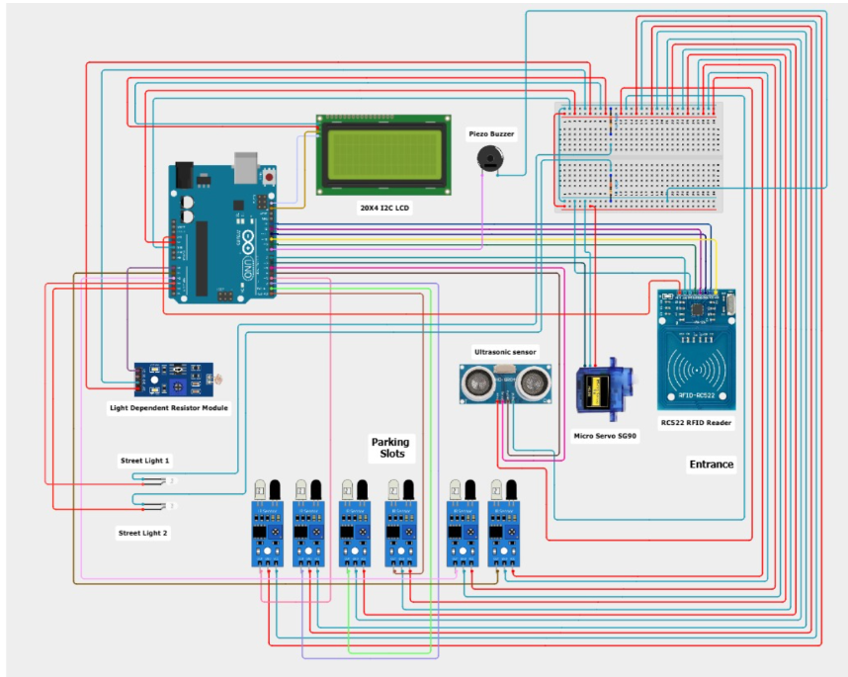
Fig. 4.1: Circuit Diagram - ESP32, IR Sensors, Servo Motor, LCD, LEDs and Buzzer
Fig. 4.1 shows how the ESP32 acts as the central node: each IR sensor feeds its slot's occupancy signal to the ESP32, which in turn drives the LCD, the per-slot LEDs, the buzzer and the gate servo based on the aggregated slot status.
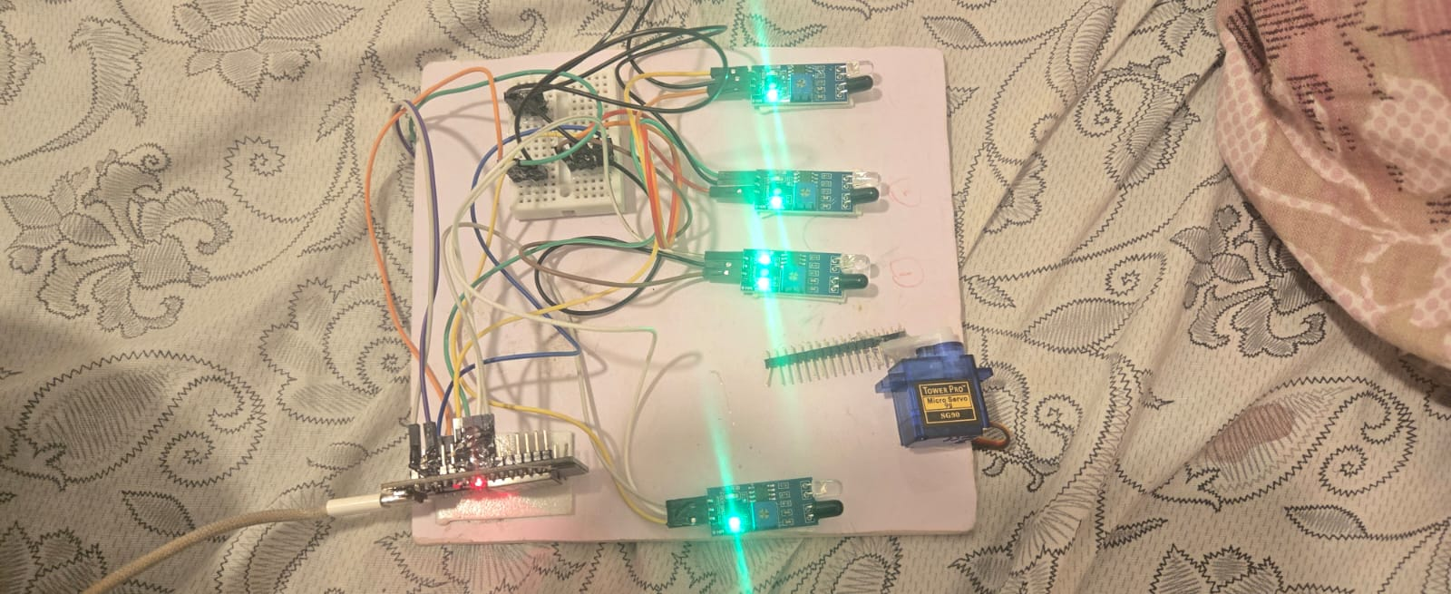
Fig. 4.2: Hardware Prototype Setup - ESP32, IR sensors, breadboard and servo motor wired for bench testing

Module 1 - Hardware & IoT Data Acquisition
- IR sensors detect whether each parking slot is occupied or vacant.
- The ESP32 microcontroller collects and processes sensor data from all four slots.
- Sensor data is transmitted to the database over Wi-Fi in real time.
- The 16x2 LCD displays the current number of available parking slots.
- Per-slot LEDs indicate status directly at the slot (Green - Vacant, Red - Occupied).
- The servo motor automatically opens and closes the parking gate.
- The buzzer provides an audible alert when a vehicle enters the parking area.
- Together these give real-time monitoring of parking slot availability at the hardware level, before any data reaches the database.

Module 2 - Database Management
- Receives the real-time slot status sent by the ESP32 over Wi-Fi.
- Stores data across the five normalized tables: User, Vehicle, ParkingSlot, ParkingRecord and Sensor.
- Updates the ParkingSlot status automatically whenever a linked Sensor value changes.
- Creates a new ParkingRecord row, with entry time, whenever a vehicle enters an available slot.
- Updates the same ParkingRecord with an exit time when the vehicle leaves.
- Uses foreign keys (VehicleID, SlotID, UserID) to keep Vehicle, User and Slot data correctly linked.
- Provides the query interface that the web application reads from to display slot status.

Module 3 - Web Application
- Connects to the database to fetch the latest parking slot status.
- Displays free and occupied slots to the user in real time.
- Refreshes automatically, so users always see current availability.
- Presents a simple interface so no manual searching is needed.
- Helps users pick a slot before arriving at the parking area, reducing traffic near the entrance.

4.3 Test Plan & Verification
Requirement | Test Method |  |  | Acceptance Criterion
IR sensor detects occupancy correctly | Manually place/remove an object at each of the 4 slots and observe LED/LCD |  |  | LED and LCD count change correctly for every slot
ESP32-to-database update | Change a slot's physical status and query the ParkingSlot table |  |  | Row status updates within the 5-second target
Gate actuation | Trigger the entry-detection sensor and time the servo response |  |  | Gate opens within 2 seconds of trigger
Web dashboard accuracy | Compare dashboard counts to the ParkingSlot table and physical slot state |  |  | All three (physical, database, dashboard) agree
Referential integrity | Attempt to insert a ParkingRecord with an invalid SlotID/VehicleID |  |  | Insert is rejected by the foreign-key constraint
Specification |  | Required Value | Achieved Value |  | Status (Pass/Fail)
Sensor-to-database update latency |  | <= 5 s | ~2-3 s (Wi-Fi, local network) |  | Pass
Gate actuation delay |  | <= 2 s | ~1 s |  | Pass
Monitored slots |  | 4 | 4 (3 wired continuously in demo run) |  | Pass
Database normal form |  | 3NF | 3NF (verified against Section 3.5) |  | Pass

4.4 Results
Fig. 4.3 and Fig. 4.4 show the web dashboard reading live data from the database at two different points during testing: with all monitored slots occupied, and after one slot was freed.

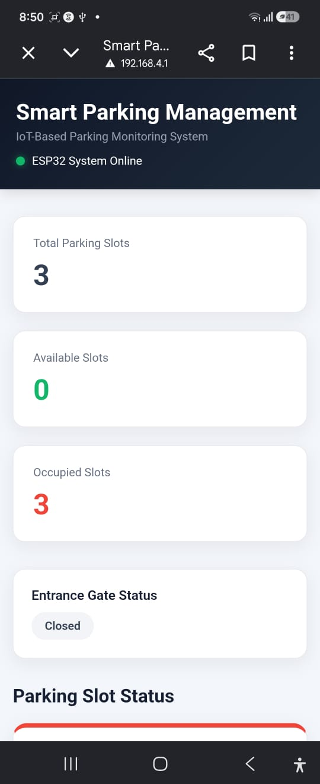
Fig. 4.3: Web Dashboard - 3 total slots, 0 available (all occupied)

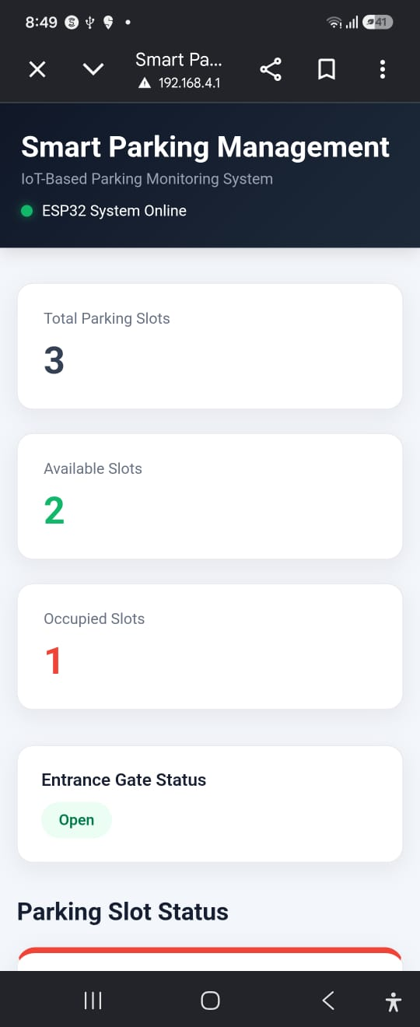
Fig. 4.4: Web Dashboard - 3 total slots, 2 available after a vehicle exits
The dashboard's Available/Occupied counters changed from 0/3 to 2/3 immediately after a monitored IR sensor was cleared, confirming that the ESP32-to-database-to-dashboard chain functions as designed for the demo hardware set.
Criteria | Manual/Existing System | Our Proposed System
Slot detection | Manual checking by staff | Automatic via IR sensors
Time to find a slot | Several minutes | Instant (checked on app)
Accuracy | Prone to human error | Sensor-based, more accurate
Real-time updates | Not available | Yes, live status
Record keeping | Manual/paper-based | Stored in database automatically
Traffic near entrance | Higher (searching cars) | Reduced (users know slot in advance)

4.5 Data Analysis & Engineering Judgment
The measured sensor-to-database latency (approximately 2-3 seconds on a local Wi-Fi network) comfortably met the 5-second target, which is adequate for a pedestrian-paced use case such as checking a dashboard before walking to a slot; it would need to be re-measured on a congested or shared network before being relied on at a larger facility. The one deviation observed during testing was that only three of the four wired IR sensors were active in the demonstration run shown in Fig. 4.3-4.4 (the dashboard reports 'Total Parking Slots: 3'); this reflects the bench-test wiring configuration at the time of capture rather than a design limitation, since the schema and firmware both support the full four-sensor set described in Section 4.2.

4.6 Comparison with Existing Solutions & Achievement of Objectives
Objective | Evidence | Achievement (Fully/Partially/Not Achieved)
Develop an IoT-based smart parking system using IR sensors and ESP32 | Circuit built and bench-tested (Fig. 4.1, 4.2) | Fully Achieved
Design an ER model and normalized relational database | ER diagram and 3NF schema (Fig. 3.2, 3.3; Section 3.5) | Fully Achieved
Monitor parking slots in real time and transmit status over Wi-Fi | Latency test in Section 4.3 (~2-3 s) | Fully Achieved
Display parking availability through a web application | Dashboard screenshots (Fig. 4.3, 4.4) | Fully Achieved
Evaluate against manual system and identify scaling paths | Comparison table (Section 4.4); future work (Section 5.2) | Partially Achieved - evaluated on a 3-4 slot prototype, not yet at facility scale

4.7 Strengths & Limitations

Strengths
- Low-cost hardware (IR sensors, ESP32, servo) suitable for student-scale prototyping.
- Normalized relational schema avoids redundant storage of owner/slot data and enforces referential integrity via foreign keys.
- Clear separation of concerns across three modules (hardware acquisition, database management, web application) makes each layer independently testable.

Limitations
- Depends on a stable Wi-Fi connection; no offline buffering of sensor events was implemented.
- IR sensors can misread if blocked by dust or foreign objects, requiring periodic physical maintenance.
- Currently sized for a small number of slots (3-4) and has not been load-tested for a large multi-slot facility.
- No application-layer authentication on the ESP32-to-database link in the current prototype (flagged as a residual risk in Section 3.7).

4.8 Project Planning, Roles & Budget
Milestone |  | Planned Duration |  |  | Status
Requirement analysis & ER modeling |  | Week 1-2 |  |  | Completed
Schema design & normalization |  | Week 2-3 |  |  | Completed
Hardware assembly & sensor calibration |  | Week 3-4 |  |  | Completed
ESP32 firmware & database integration |  | Week 4-6 |  |  | Completed
Web application development |  | Week 5-6 |  |  | Completed
Testing, results collection & report writing |  | Week 6-7 |  |  | Completed
Student | Assigned Responsibility |  |  | Actual Contribution
P. Jessica Hephzbah | System architecture, hardware integration, normalization |  |  | As assigned (Section: Individual Contribution Statement)
K. Tejaswi | ER modeling, relational database, Module 2 |  |  | As assigned (Section: Individual Contribution Statement)
S. Swetha | Web application, results documentation |  |  | As assigned (Section: Individual Contribution Statement)
Item |  |  | Estimated Cost |  |  | Actual Cost
ESP32 microcontroller |  |  | Rs. 500 |  |  | Rs. 500
IR sensors (x4) |  |  | Rs. 200 |  |  | Rs. 200
Servo motor |  |  | Rs. 150 |  |  | Rs. 150
LCD 16x2 with I2C |  |  | Rs. 200 |  |  | Rs. 200
LEDs, buzzer, breadboard, jumper wires |  |  | Rs. 250 |  |  | Rs. 250
Total |  |  | Rs. 1300 |  |  | Rs. 1300

CHAPTER 5
CONCLUSION, FUTURE WORK AND REFLECTION

5.1 Conclusion
This project set out to replace manual, error-prone parking-slot checking with an automated pipeline built on IoT sensing and a properly designed relational database. The completed prototype uses IR sensors and an ESP32 microcontroller to detect slot occupancy in real time, an Entity-Relationship model normalized to Third Normal Form to store User, Vehicle, ParkingSlot, ParkingRecord and Sensor data without redundancy, and a web application that reads this database to show drivers which slots are free before they arrive. Testing confirmed that slot-status changes propagate from sensor to database to dashboard within a few seconds, that foreign-key relationships keep the data consistent, and that the resulting system is faster, more accurate and better recorded than the manual approach it replaces. Overall, the project demonstrates that combining low-cost IoT hardware with disciplined ER modeling and normalization produces a smart parking system that is both practically usable at prototype scale and structurally ready to be extended to larger, real-world parking facilities.

5.2 Future Work
- Scale the sensor network and database to a larger number of slots, and load-test the Wi-Fi and database layers at that scale.
- Add application-layer authentication/encryption on the ESP32-to-database link to close the security gap noted in Section 3.7.
- Incorporate RFID-based vehicle identification or number-plate recognition (as seen in the literature review, Section 2.2) to automate entry linking to a specific Vehicle/User.
- Add a billing/fee module on top of the existing ParkingRecord entry/exit timestamps.
- Introduce offline buffering on the ESP32 so sensor events are not lost during brief Wi-Fi outages.

5.3 Professional Learning & Individual Reflection

New Knowledge Acquired
- Practical interfacing of IR sensors, a servo motor, an LCD and a buzzer to a single ESP32 controller.
- Translating a real-world scenario into an ER model and then into a normalized relational schema (1NF-3NF).
- Connecting an embedded Wi-Fi device to a backend database and a web front-end as one working pipeline.

Engineering & Professional Skills Developed
- Requirement analysis and trade-off evaluation between competing design alternatives (Section 3.4).
- Structured testing and verification against acceptance criteria rather than ad-hoc checking.
- Team-based division of responsibilities across hardware, database and web-application workstreams.

Individual Reflection - P. Jessica Hephzbah
The most difficult problem I faced was keeping the ESP32 firmware and the relational schema in agreement as the design evolved; an early version of the schema did not have a separate Sensor table, which made it hard to track sensor-level status independently of slot-level status. Splitting Sensor out as its own entity, linked one-to-one with ParkingSlot, was the key engineering decision I made, based on the normalization evidence discussed in Section 3.5. Working on the system architecture also taught me how much of a real embedded project is about getting the interfaces between layers right, not just each layer in isolation. If I were to redesign this, I would add basic authentication on the Wi-Fi link from the start rather than treating it as future work.

Individual Reflection - K. Tejaswi
The hardest part of my work was deciding how many entities the ER model actually needed; an early draft merged Vehicle and ParkingRecord into one entity, which caused repeated owner and vehicle data across records. Splitting them, and adding explicit foreign keys, was the key decision, justified by the redundancy this removed. Building the relational schema from the ER diagram gave me a much clearer sense of how normalization theory maps onto an actual working database. If repeated, I would document the foreign-key constraints more explicitly before implementation rather than after.

Individual Reflection - S. Swetha
My most difficult problem was keeping the web dashboard synchronized with a database that could change at any moment from hardware events; the key decision was to have the dashboard poll and refresh automatically rather than requiring a manual reload, based on the responsiveness the requirements in Section 3.1 called for. Through this I learned how much front-end design depends on the reliability of the layers underneath it. If I repeated this project, I would add clearer status indicators for when the dashboard's data might be stale due to a lost connection.

REFERENCES
[1] D. Ashok, A. Tiwari, and V. Jirge, "Smart Parking System using IoT Technology," in 2020 International Conference on Emerging Trends in Information Technology and Engineering (ic-ETITE), IEEE, Feb. 2020, pp. 1-7.
[2] M. Rajasekaran, B. Hari Prasanna, S. Manoj Kumar, K. Pradeep Kumar, and R. G. Yugeshram, "Smart Parking Management Using IoT and ESP32: A Real-Time Monitoring System," in Proc. 4th Int. Conf. on Information Technology, Civil Innovation, Science, and Management (ICITSM 2025), Part II, Tiruchengode, Tamil Nadu, India, 2025.
[3] J. W. Simatupang, A. M. Lubis, et al., "IoT-based smart parking management system using ESP32 microcontroller," in 2022 9th Int. Conf. on Electrical Engineering, Computer Science and Informatics (EECSI), IEEE, 2022, pp. 305-310.
[4] H. S. Won, S. Saon, S. W. Mudjanarko, et al., "IoT based vehicle parking model with mobile apps software," in 2021 IEEE 19th Student Conf. on Research and Development (SCOReD), IEEE, 2021, pp. 197-200.
[5] "Number plate recognition smart parking management system using IoT," ScienceDirect, Results in Engineering, 2024.
[6] "IoT-Based Automated Smart Parking Fee Management System," in 2025 IEEE Int. Students' Conf. on Electrical, Electronics and Computer Science (SCEECS), IEEE, 2025.
[7] IEEE Standard 802.11, IEEE Standard for Information Technology - Wireless LAN Medium Access Control (MAC) and Physical Layer (PHY) Specifications, IEEE.
[8] IEEE Standard 1451, IEEE Standard for a Smart Transducer Interface for Sensors and Actuators, IEEE.
[9] IEEE Standard 830, IEEE Recommended Practice for Software Requirements Specifications, IEEE.
Note: full-text access, exact page numbers and any additional sources actually consulted should be verified and completed by the student team before final submission.

APPENDICES

Appendix A - Detailed Calculations
Latency and timing calculations supporting Section 4.3/4.5 (sensor-to-database update timing, gate actuation timing) to be attached here from raw test logs.

Appendix B - Engineering Drawings / Schematics
Circuit diagram (Fig. 4.1) and system architecture diagram (Fig. 1.1/3.1) are reproduced in full resolution in this appendix for reference.

Appendix C - Source Code / Code Repository Information
Only essential code excerpts are included in the main report body. The complete ESP32 firmware, database schema scripts and web application source code are maintained in the team's project repository; repository link/branch to be added by the students before submission.

Appendix D - Datasheets
Datasheets for the ESP32 module, IR sensors, servo motor and LCD/I2C module to be attached here.

Appendix E - Experimental / Raw Data
Raw sensor logs and database query outputs used to derive the results in Section 4.4 to be attached here.

Appendix F - Ethics / Institutional Approval
Not applicable - this project does not involve human-subject data collection beyond the minimal parking-record fields described in Section 3.7.

Appendix G - Project Meeting / Progress Records
Weekly progress notes corresponding to the milestones in Section 4.8 to be attached here.

Appendix H - User/Industry Feedback
Not collected for this prototype; recommended as part of future work (Section 5.2) before facility-scale deployment.

Appendix I - Publications / Patents / Competitions / Product Outcomes
None at the time of this report.

Appendix J - Individual Contribution Evidence
Supporting evidence (commit history, test logs, drafts) for the Individual Contribution Statement to be attached here by each student.

CAPSTONE PROJECT OUTCOME MAPPING SHEET
(To be completed by the department/faculty assessor)
Outcome | SO / Area | Evidence Location in This Report
Complex engineering problem formulation | SO1 | Ch. 1, Ch. 2
Engineering design under constraints | SO2 | Ch. 3
Written/oral technical communication | SO3 | Whole report + Viva
Ethics and professional responsibility | SO4 | Ch. 3 (3.7)
Teamwork and leadership | SO5 | Ch. 4 (4.8)
Experimentation, analysis, engineering judgment | SO6 | Ch. 4 (4.3-4.6)
Independent acquisition of new knowledge | SO7 | Ch. 5 (5.3)
Standards | SO2 | Ch. 3 (3.2)
Sustainability and societal/environmental impact | SO2/SO4 | Ch. 3 (3.7)
Risk assessment and mitigation | SO2/SO4 | Ch. 3 (3.7)
Security considerations | Relevant SO | Ch. 3 (3.7)
Integrated/system-level engineering | SO1/SO2 | Ch. 3 (3.5)
Project planning and management | SO5 | Ch. 4 (4.8)
Individual contribution | SO1-SO7 | Contribution Statement + Ch. 4 (4.8)

